Plumas County
Engineering Department
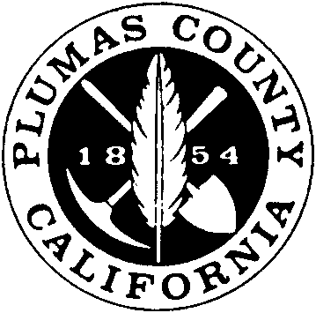

Record of Surveys

Office of the County Engineer
Record of Survey Map Statements

“Record of Survey Submittal Checklist”
must accompany Submittal to be considered complete.

8764.5. Record of survey – required statements

Statements shall appear on the map as follows:

SURVEYOR’S STATEMENT

This map correctly represents a survey made by me or under my direction in conformance with the requirements of the Professional Land Surveyors’ Act at the request of
in , 20 .
Name of Person Authorizing Survey

(Signed and sealed)
L.S. (or R.C.E.) No.

COUNTY SURVEYOR’S STATEMENT

This map has been examined in accordance with Section 8766 of the Professional Land Surveyors’ Act this day of , 20 .

(Signed and sealed) Tom Hunter

L.S. (or R.C.E.) No. RCE 30515

RECORDER’S STATEMENT

Filed this day of , 20 , at .m. in Book
Records of Survey at page , at the request of The Plumas County Surveyor.

Filing Fee:
File No.:

County Clerk-Recorder:
Marcy DeMartile
Other Statements

For use when land is conveyed to or from a governmental agency and is not shown on the latest Assessor roll:

County Surveyors Certificate
(On face of map or separate document per PLS 8762.5)
(Add as the second paragraph to County Surveyors Certificate)

I hereby certify that this map is in compliance with the provisions of the Subdivision Map Act, Division 2, (commencing with section 66410) of Title 7 of the Government Code and any applicable ordinance enacted pursuant thereto.

For use when a survey shows adjusted Lot Lines:

Lot Line Adjustment Note

This record of Survey was prepared to reflect a Lot Line Adjustment for which a resolution is recorded as Document #_________________________.

