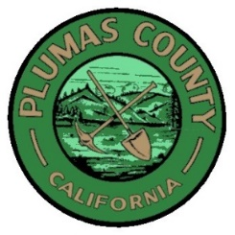

Notice Regarding Confirmed Cases of

COVID-19 at the Workplace

Dear [Agency] Community,

I am writing to share with you that [an employee of our agency] [member of the community] who was last at our [building(s)] [time period] has tested positive for COVID-19. I realize that this news may cause concerns and raise questions. Please know that we take our obligation to appropriately balance privacy and community safety interests very seriously, which is why I am only able to share limited information. [We are in the process of individually contacting those individuals whom we have reason to believe may have had increased exposure.]

We are following best practices to respond to the situation based on guidance from local health officials and other public health authorities, such as the CDC. To that end, we are using this moment to remind everyone of the need to maintain social distancing at all times, to practice thorough hygiene, to monitor for symptoms, and if symptoms arise, to stay away from others and seek medical advice. Before the stay-at-home order, we also practiced social distancing and implemented deep cleaning protocols. This included disinfecting shared surfaces that were frequently touched (wiping down desks, cleaning doorknobs, railings, phones, etc.). We will continue to follow these procedures.

We wish our [community member] [employee] a swift recovery and thank them for notifying the [Agency] directly.

Sincerely,

[Insert Name]
[Insert Tittle]

